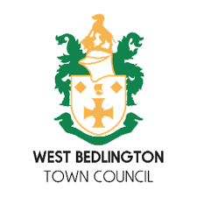

To:

ALL MEMBERS OF WEST BEDLINGTON TOWN COUNCIL STAFFIING COMMITTEE

You are hereby requested to attend a meeting of WEST BEDLINGTON TOWN COUNCIL STAFFING COMMITTEE to be held at Bedlington Community Centre, Front Street West, Bedlington on Thursday 10th September 2026 after the conclusion of the full town council meeting.

The agenda for the meeting is set out below.

Steven Young
Town Clerk 3rd September 2026

- ELECTION OF A COMMITTEE CHAIR

- APOLOGIES FOR ABSENCE
To receive apologies for absence from Councillors

- ACCEPTANCE OF THE COMMITTEES’ TERMS OF REFERENCE
Details distributed to members of the committee

- RESOLUTION TO EXCLUDE MEMBERS OF THE PUBLIC
The agenda relates solely to employment issues.
Under the Public Bodies (Admission to Meetings) Act 1960, the public and representatives of the press and broadcast media be excluded from the meeting during the consideration of the following items of business as publicity would be prejudicial to the public interest because of the confidential nature of the business to be transacted.

- STAFF REGRADING AND POTENTIAL FINANCIAL IMPACT
Details distributed to members of the Committee.
To make any recommendations to Full Council for approval.

- CLOSE OF MEETING
The Chair will close the meeting.

