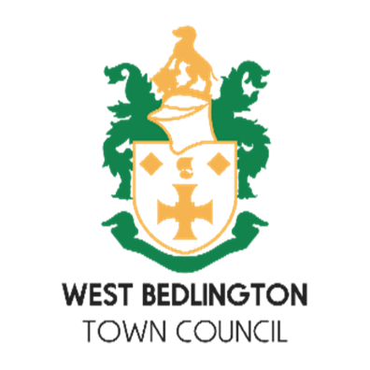
Bedlington Festival Fun Dog Show
Saturday 7th June 2025
Sponsored by West Bedlington Town Council

Owner’s name
Address
Telephone number
Email

Dog Details
Name
Age
Breed

Categories – please tick the category you wish to enter
Most Obedient
Waggiest Tail
Most Handsome Boy
Prettiest Girl
Best Puppy (under 12 years)
Best Golden Oldie (8 years plus)
Best Trick
Best Fancy Dress

The deadline to enter this fun competition is 15th May 2025. Please email your entry to clerk@westbedlingtontowncouncil.gov.uk or return your form to West Bedlington Town Council, Bedlington Community Centre, Front Street West, Bedlington, NE22 5TT.

